The main idea of this lab exercise to give hands on experience on

grep

constructs

command line arguments

1. write a shell script to get value the pattern and file name from the user and check the pattern exists or not. If the pattern exists print the relavent

message , if pattern not found print relevent message.

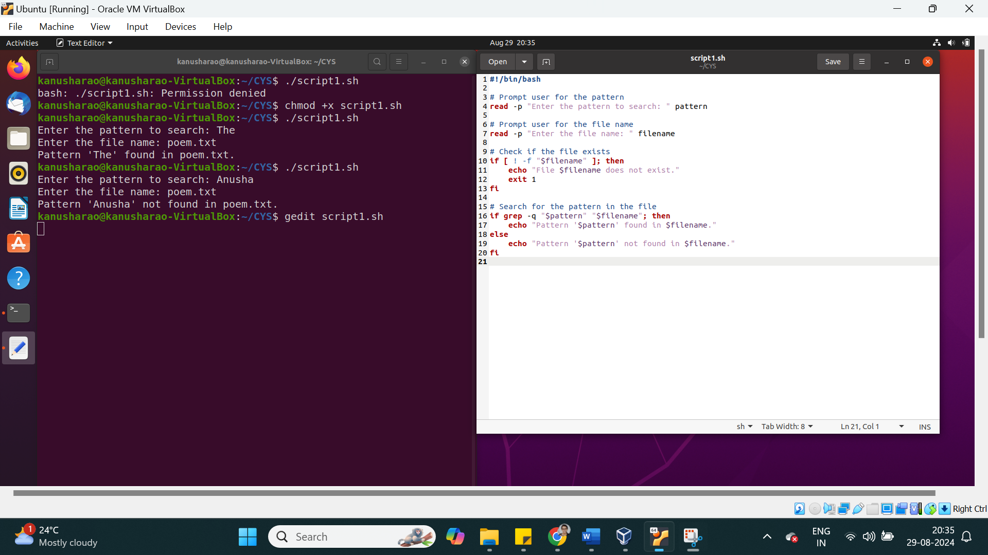

2. Modify the above script to pass the arguments from command line arguments.

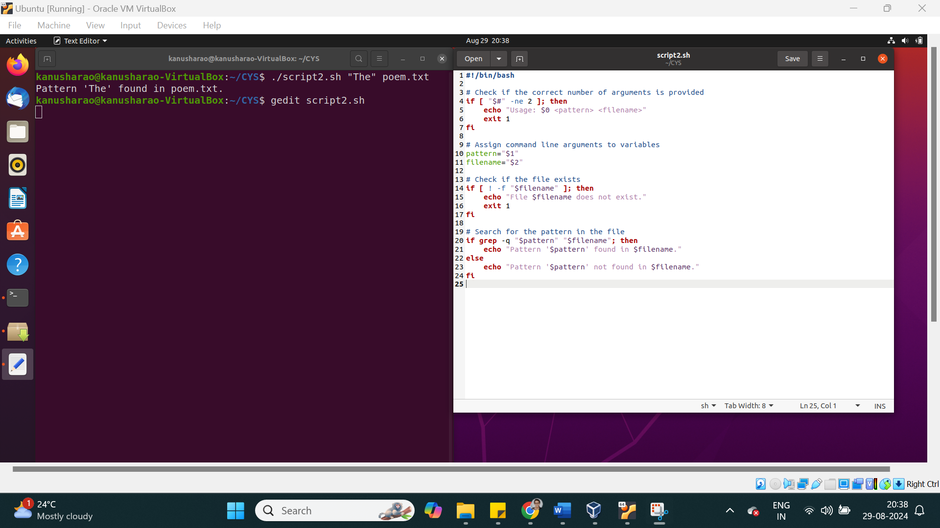

3. Modify the above script to pass the values inside the script.

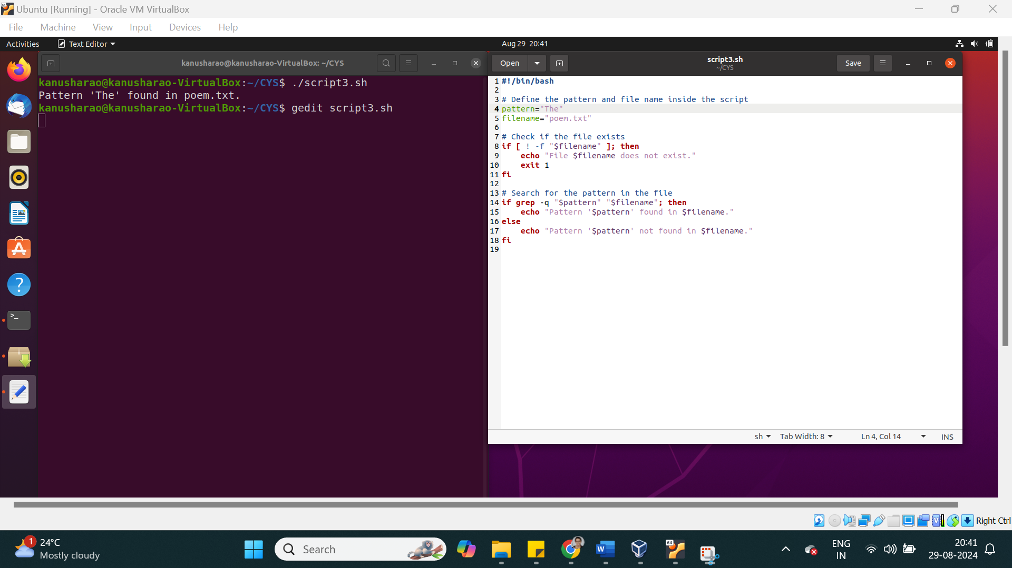

4. validate the script (script 1, script 2)

- the file exists or not

- arguments passed or not

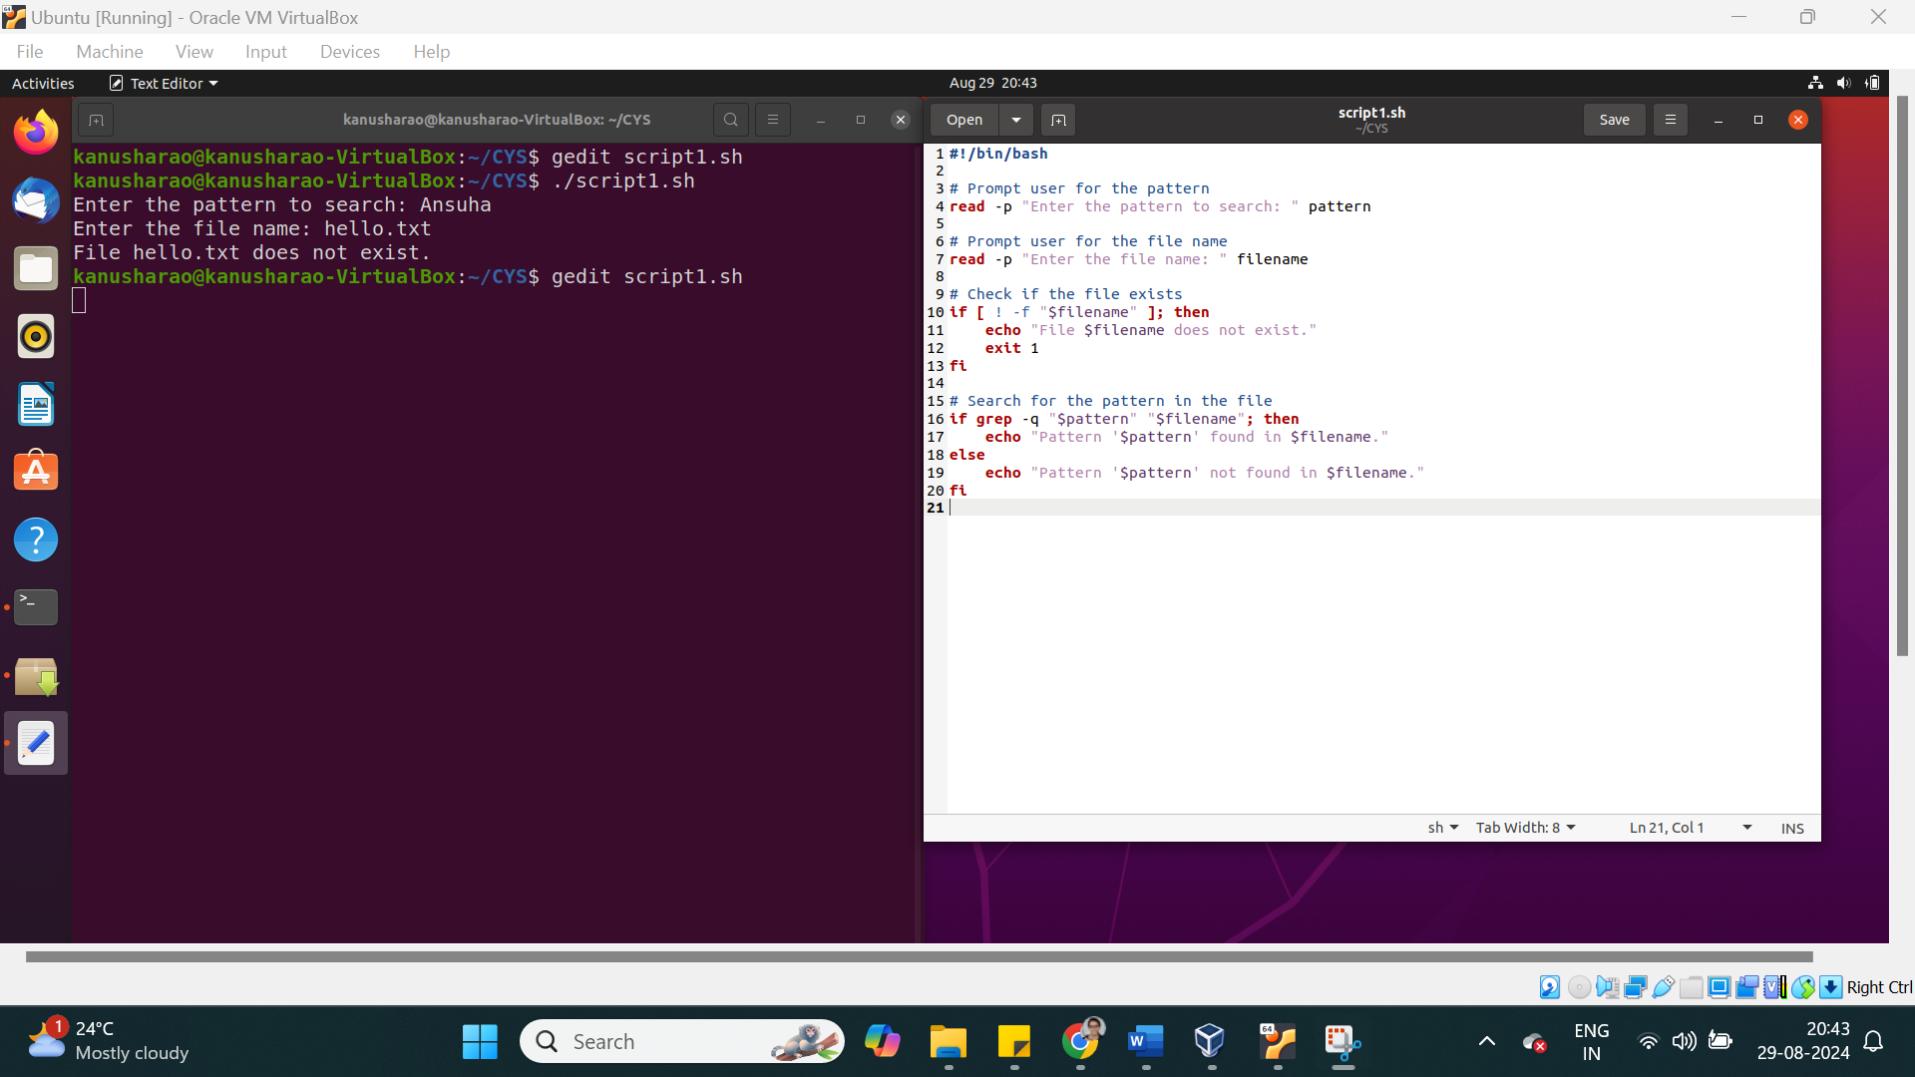

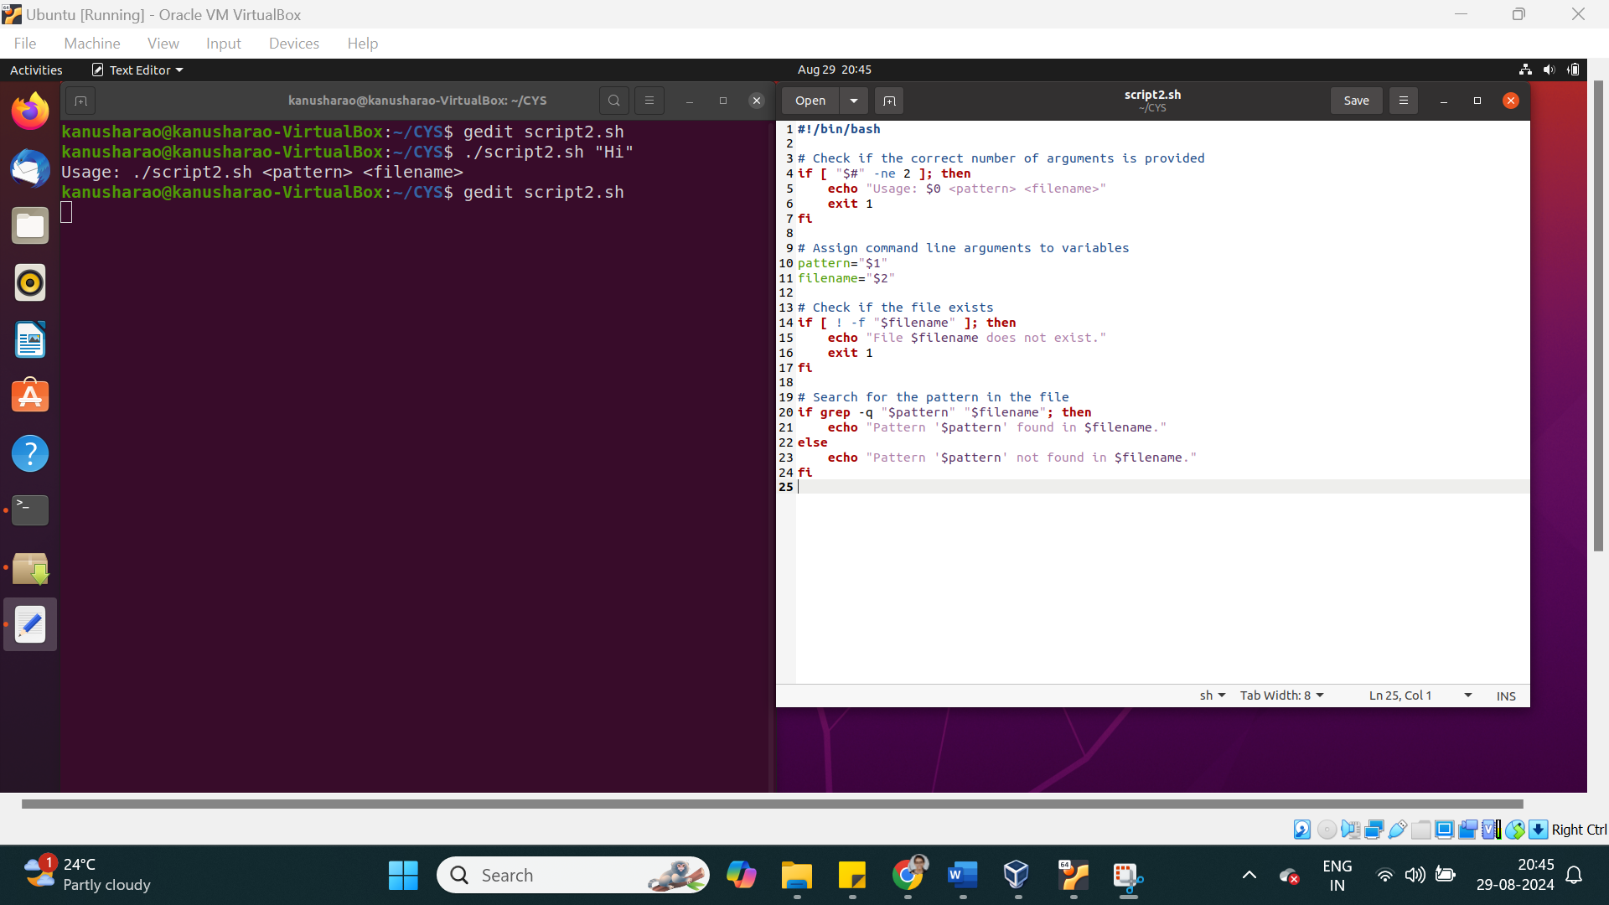

5. Apply grep commands

Note: Make sure to use the options -e -c -n -q -s -f -A -B -C -i -h, -l -o -w

Frame the questions (as per your choice)

to extract user information

to extract network information

to extract login details

**1. Extracting User Information**

**Question 1: How can you extract all lines that contain the word "user" (case-insensitive) from a system configuration file and display the line numbers?**

**Question 2:** How can you count the number of users that have a specific shell, such as /bin/bash, in the /etc/passwd file?

**Question 3:** How can you extract the usernames that start with a specific pattern, such as "admin", and display only the matching part?

**Question 4:** How can you display lines before and after a match for the word "network" in a log file?

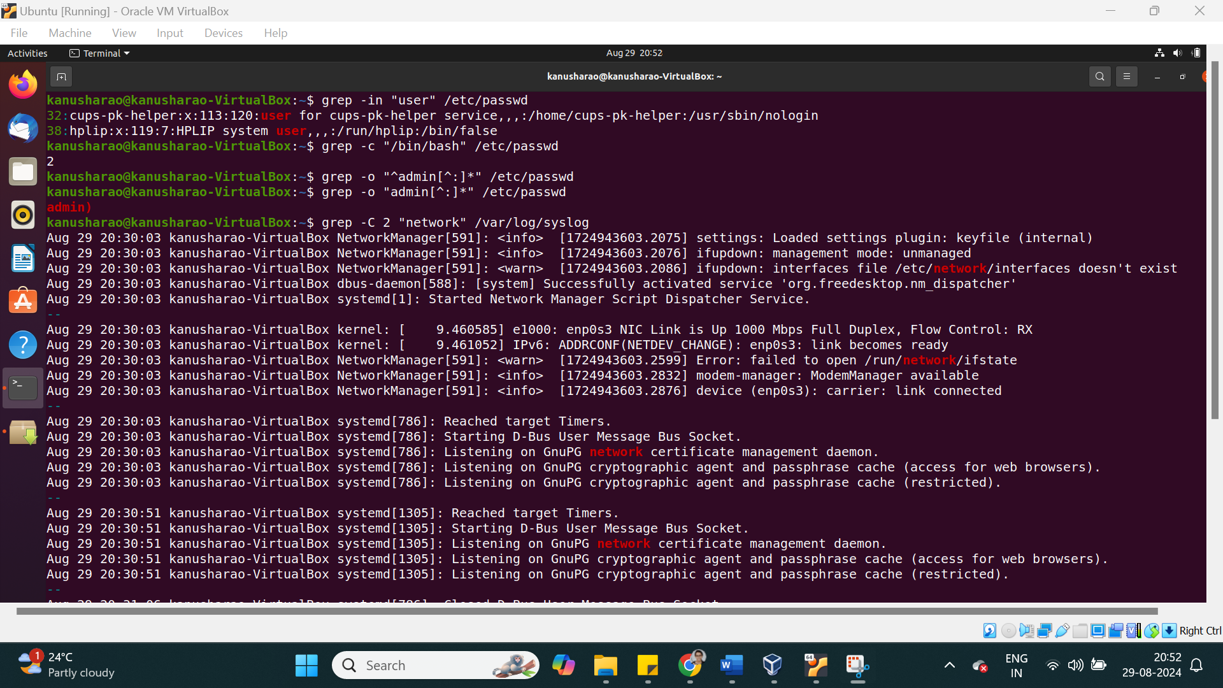

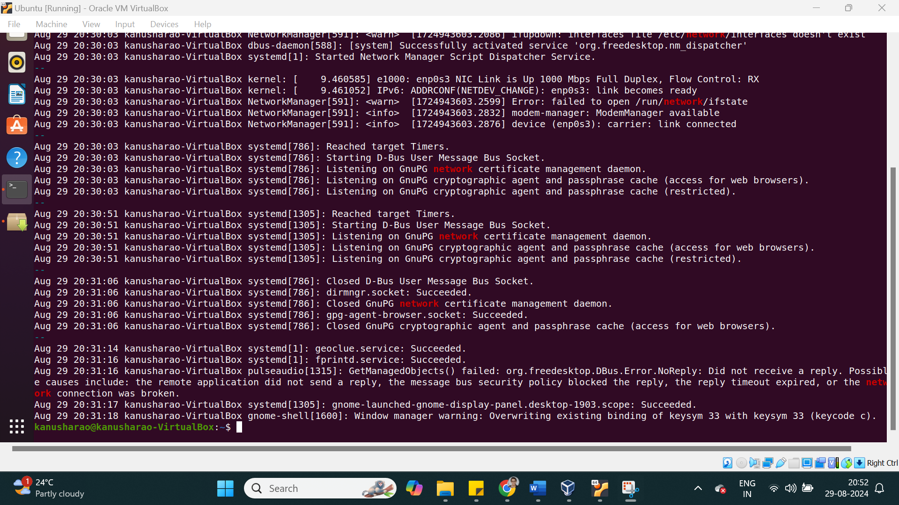

**Question 5:** How can you silently check if the word "hello" exists in poem.txt file?

**Question 6:** How can you search for multiple patterns, like "hello" and "The", in poem.txt file?

**Question 7:** How can you find the lines containing the exact word "auth" in the authentication log?

**Question 8:** How can you search for the word "failed" in all log files within a directory and display only the filenames?

